Periodically, a company processes the retirement of some of its employees. In this question, you will write methods to help the company determine whether an employee is eligible to retire and to process the retirement of all eligible employees.

The Java interface **Employee** is implemented by objects that represent employees. The interface is declared as follows.

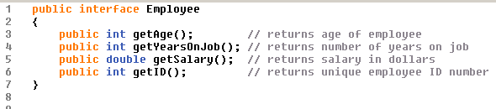

The **Company** class is declared as follows.

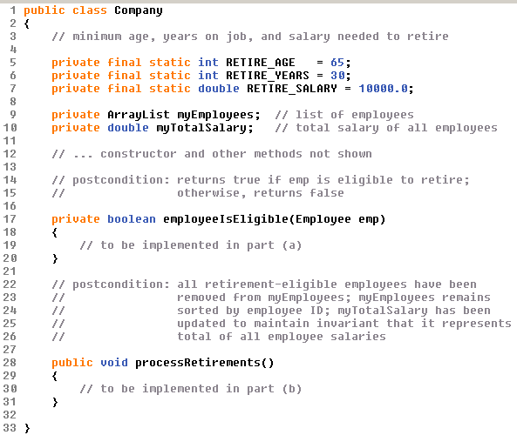

**Two class constraints that must be maintained by Company objects:**

* **The instance variable myEmployees is sorted by employee ID.**
* **The instance variable myTotalSalary is the total of all employee salaries.**

The **Company** constructor will establish these invariants as true initially. All **Company** methods must ensure that the invariants remain true.

**Part A**

An employee is eligible for retirement if (s)he meets at least two of the following requirements.

1. The employee is at least **RETIRE_AGE** years old.
2. The employee has worked for at least **RETIRE_YEARS** years.
3. The employee's salary is at least **RETIRE_SALARY**.

Write the private **Company** method **employeeIsEligible**, which is described as follows. Method **employeeIsEligible** returns a boolean value that indicates whether the employee represented by parameter **emp** is eligible for retirement, using the rules above.

Complete method **employeeIsEligible** below.



**Part B**

(*Assume all import statements you need are made. You do not need to write import statements*).

Write the **Company** method **processRetirements**, which is described as follows. Method **processRetirements** removes all retirement-eligible emloyees from ArrayList **myEmployees** and maintains the two class invariants described above: the ArrayList is maintained in order by employee ID and **myTotalSalary** is the total of all salaries of the remaining employees.

In writing **processRetirements**, you may call method **employeeIsEligible**, specified in part (a). Assume that **employeeIsEligible** works as specified, regardless of what you wrote in part (a).

Complete method **processRetirements** below.

